Muhand Jumah

Developing Class System

E-R Diagram

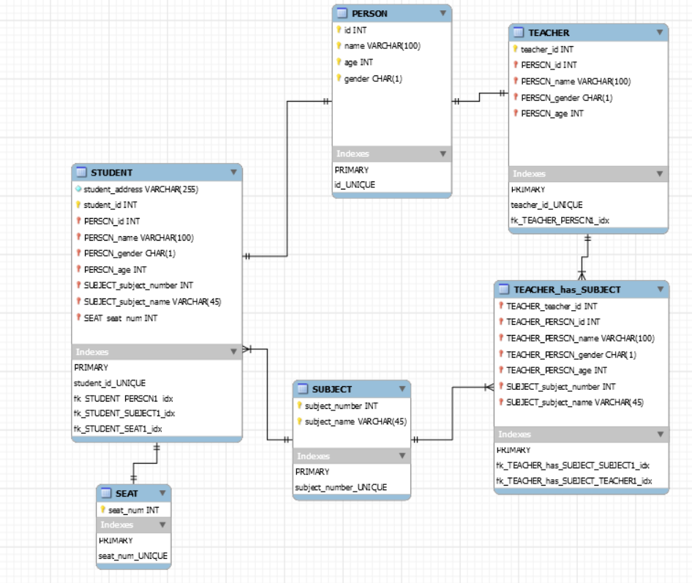

//////////////////////////////////////////////////////////////////////////////////////////////////

Converting to a relation.

NOTE: Anything that has a * next to it, it means a primary key.

Anything that is underlined, it means a ForeignKey

PERSON(*id, *name, *age, *gender)

STUDENT(*student_id, student_address, PERSON_id, PERSON_name, PERSON_gender, PERSON_age, SUBJECT_subject_name, SUBJECT_subject_number, SEAT_seat_num)

TEACHER(*teacher_id, PERSON_id, PERSON_name, PERSON_gender, PERSON_age)

TEACHER_has_SUBJECT(TEACHER_teacher_id, TEACHER_PERSON_id, TEACHER_PERSON_name, TEACHER_PERSON_gender, TEACHER_PERSON_age, SUBJECT_subject_number, SUBJECT_subject_name)

SEAT(*seat_num)

SUBJECT(*subject_number, *subject_name)

//////////////////////////////////////////////////////////////////////////////////////////////

Scripts

A separate File, because the code I wrote exceeds 110 lines, so I don’t want to make this file large.